AP Calc AB Name: _______________

______________ _____________
WS Assessment

Target 3:
Continuity

I can:
- Justify conclusions about continuity at a point using the definition
- Determine intervals over which a function is continuous.
- Determine values of x or solve for parameters that make discontinuous functions continuous, if possible.

Unit 1: Limits and Continuity

HW Target 3
Unit 1 Progress Check MCQ Part C
Given function below, complete the table

The function given in the graph is discontinuous at every point x = c. Indicate the “fail” test by check mark in the following column table
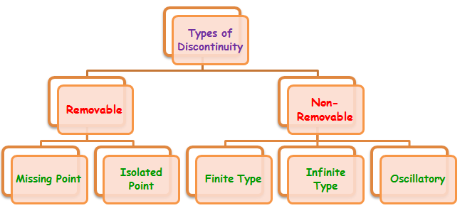
Continuous means the graph have no "breaks", "gaps" or "holes".

Extra: Sketch the graphs of each of the five types (google)

For the following function, use the “fail” test table to indicate the continuous, and discontinuous points.
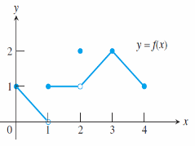 | x = c | Limit does not exist | Function is not defined | Limit does not equal Function
 | x = 0
 | x = 1
 | x = 2
 | x = 3
 | x = 4
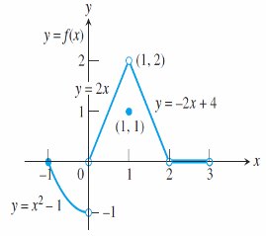
 | x=-1
 | x = 0
 | x = 1
 | x = 2
 | x = 3

Sketch a possible graph for a function f that has the stated properties.
- f (1) has a nonremovable discontinuity.
- f (2) exists, $\lim_{x→2^{+}}{f(x)}=f(2)$, but $\lim_{x→2^{-}}{f\left(x\right)=DNE}$
- f (3) exists but $\lim_{x→3}{f(x)}$) does not.
- f (4) exists, $\lim_{x→4}{f(x)}$ exists, but f is not continuous at x = 4.

Determine if $f(x)=\left\{\begin{aligned}\frac{x^{2}+5x-14}{x-2} if x≠2 \\ 12 if x=2\end{aligned}\right\}$ is continuous at x =2. Explain why or why not.

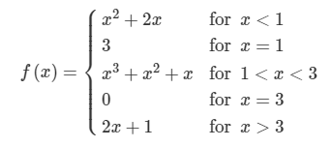
Determine if the function f(x) is continuous at x = 1, 2, 3, 4

For what value of k is the function $g(x)=\left\{\begin{matrix}x^{2}+5x , if x≤3 \\ 2x-kx , if x>3\end{matrix}\right.$ continuous ?

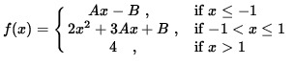
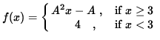

State the intervals over which a function is continuous
a. y = $\frac{1}{x}$ b. y = $\frac{x^{2}+5}{x-2}$ c. y = | x| d. y = sin (x) (radian)

e. y = $\frac{x^{2}+x-6}{x^{2}-4}$ f. y = $\sqrt{xcosx}$ g. y = tan(x) h. y = $\frac{sinx}{x}$

i. y =$\left\{\begin{matrix}\frac{x^{2}-1}{x-1}, x≠1 \\ 2 , x=1\end{matrix}\right.$ j y = $\left\{\begin{matrix}\frac{x^{2}-16}{x^{2}-3x-4}, x≠-1,4 \\ 2 , x=4\end{matrix}\right.$

Continuity versus Having a limit
If a function is continuous at a point → It is having a limit at this point
If a function is having a limit at a point → It may or may not continuous at this point
Give example by graph and algebra
continuous and limit limit but discontinuity

Determine the limit and continuity of the following at the given point (feel free to online)

$\lim_{x→3}\frac{{2x}^{2}-6x}{x^{2}-9}$ $\lim_{x→-2}\frac{x^{2}+3x+1}{x^{2}+4x+4}$

$\lim_{x→0}\frac{∣x∣}{x}$ $\lim_{x→3}\frac{\sqrt{x^{2}+4}-2}{x^{2}}$

$\lim_{x→0}\frac{{(3+x)}^{2}-9}{x}$ $\lim_{x→5}\frac{x-5}{\sqrt{x^{2}-25}}$

$\lim_{x→0}\frac{sin3x}{tan3x}$ $\lim_{x→∞}\frac{sinx}{x}$

$\lim_{x→0}\frac{sinx}{x}$ $\lim_{x→0}\frac{sin2x}{x}$

$\lim_{x→0}\frac{sin2x}{x^{2}}$ $\lim_{x→0}\frac{sinx}{\sqrt{x}}$

$\lim_{x→0} xsin\frac{1}{x}$ $\lim_{x→0}\frac{1-cosx}{x}$

$\lim_{x→0}\frac{1-cosx}{x^{2}}$ $\lim_{x→0} sin(x^{2}+1)$

Composite of Continuous Functions: If f is continuous at c and g is continuous at f (c), then the composite g f is continuous at c.
Show that $y=∣\frac{xsin(x)}{x^{2}+2}∣$ is continuous
Let f(x) = g(x) =

Therefore f(g(x)) =
Assessment
Determine if the following function is continuous
at x=1 at x = -2
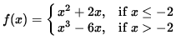
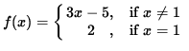

at x = 0 at x = -1
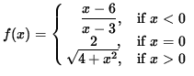
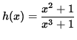

State the intervals over which a function is continuous
